Project Development Phase
Model Performance Test

Date | 26 June 2026
Team ID
Project Name | Sports Hall Booking System By Servicenow
Maximum Marks

Model Performance Testing:
Project team shall fill the following information in model performance testing template.
S.No. | Parameter | Values | Screenshot
 | Model Summary | ServiceNow-based Sports Hall Booking System developed for online sports hall reservation with booking validation and duplicate booking prevention. | 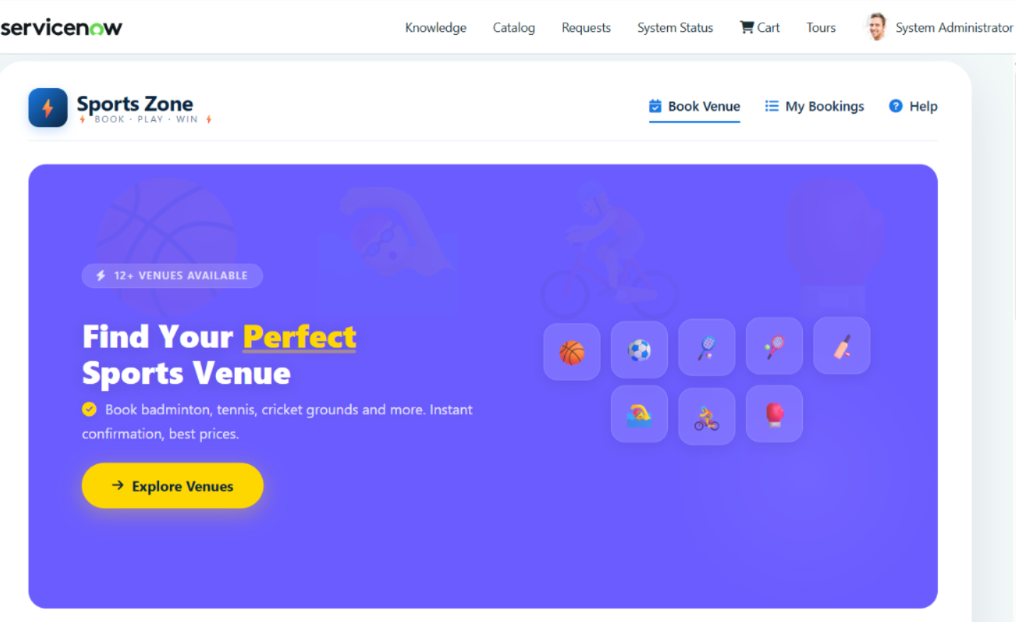
 | Accuracy | Training Accuracy: Not Applicable (Software Project).  Functional Validation: 100% (All test cases passed successfully). | 
3. | Fine Tunning Result( if Done) | Validation Result: 100%. UI improvements completed, booking validation verified, available slot checking implemented, and duplicate booking prevention working successfully. | 